]Linux commands session -3

top : to check the cpu utilizations
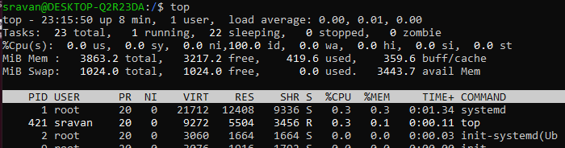
ps -ef : to get the list of running services
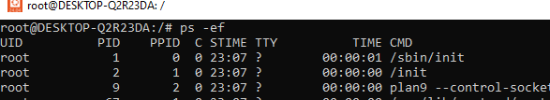

Installing nginx or any services on Ubuntu:

sudo apt update - Update your package index
sudo apt install nginx - to install nginx
sudo systemctl start nginx - to start nginx
sudo systemctl status nginx - to check status of nginx
sudo systemctl stop nginx - to stop nginx or any services
sudo kill -9 3583(process ID) – to kill the services

ps –ef | grep nginx : to check particular running services “nginx”
